

We first reverse the array, time complexity is O(n/2) since pointers only iterate through half of the elements



Now we reverse the first k elements in the array, time complexity is O(k/2) since pointers iterate through half of k elements



Then reversing the remaining

n-k elements, time complexity is O( [n-k]/2 ) since pointers iterate through half of n-k elements

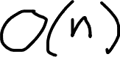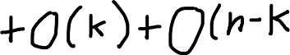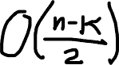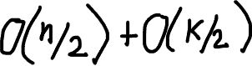

At the beginning, we start by doing k=k%len(nums) because we don’t want to rotate the array more than we need

ex:



These k have the same answer so 0%5=0, 5%5=0 and 10%5=0